Industrial Bank Co., Ltd.

December 31, 2021
Internal Control Audit Report

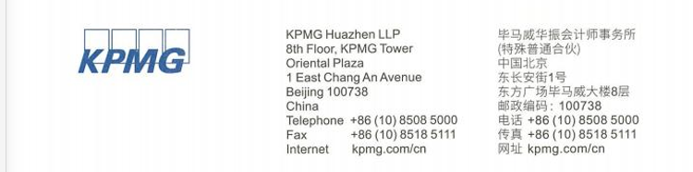

Internal Control Audit Report

KPMG Huazhen Shen Zi No.2202068
All shareholders of Industrial Bank Co., Ltd.:
In accordance with the Guidelines on Corporate Internal Control Audit and the Professional Code of Conduct for Chinese Certified Accountants, we have audited the effectiveness of internal control for the financial report issued by Industrial Bank Co., Ltd. (“Bank”) on December 31, 2021.
I. Corporate Responsibilities for Internal Control
It is the responsibility of the Board of Directors of your Bank to establish, improve and effectively implement internal control and evaluate its effectiveness in accordance with the Basic Norms of Internal Corporate Control, Guidance for Corporate Internal Control Applications, and Guidance for Corporate Internal Control Evaluation.
II. Responsibility of Certified Accountant
Our responsibility is, on the basis of implementing audit work, to express audit opinions on the effectiveness of the internal control of financial report and disclose major defects of internal control in the non-financial report that we have noticed.
III. Intrinsic Limitations of Internal Control
Internal control has its intrinsic limitations. As such, it is possible that misstatements cannot be prevented and discovered. Furthermore, it is risky to speculate the effectiveness of future internal control based on the audit result of internal control given that changes in circumstances may cause internal control to be inappropriate or reduce the degree of compliance with policies and procedures.

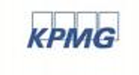
Internal Control Audit Report (Continued)
KPMG Huazhen Shen Zi No.2202068
IV. Internal Control Audit Opinion of Financial Report
We believe that your Bank has maintained effective internal control of financial report in major aspects on December 31, 2021 in accordance with the Basic Norms of Corporate Internal Control and relevant regulations.

KPMG Accounting Firms (LLP) (seal) Chinese Registered Accountants

Chen Sijie (signature and seal)

Beijing, China Wu Zhongming (signature and seal)

March 24, 2022

