Industrial Bank Co., Ltd
Internal Control Audit Report
as of December 31, 2022

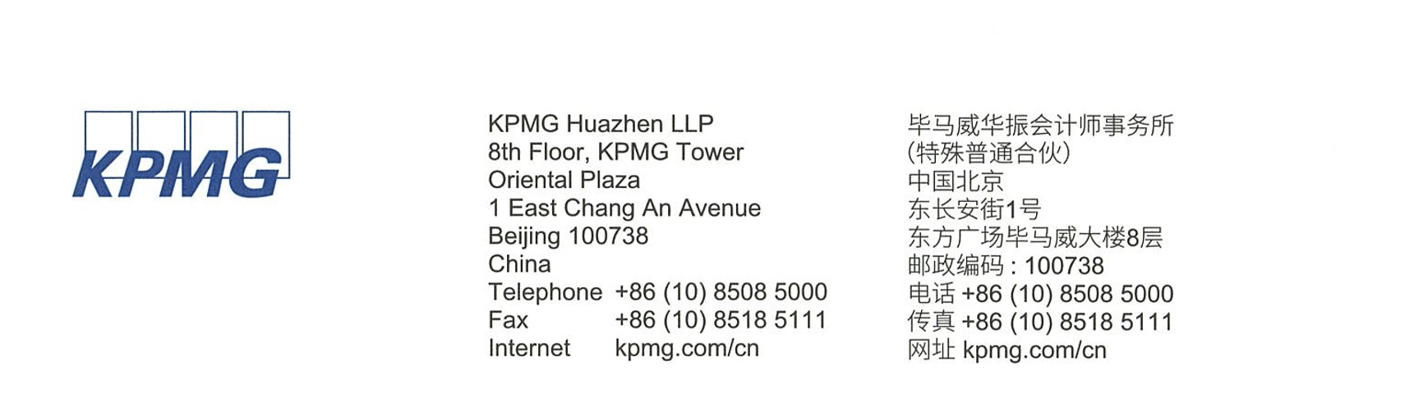

Internal Control Audit Report
KPMG Hua Zhen Audit No. 2302250

To all shareholders of Industrial Bank Co., Ltd:

In accordance with the Guidelines on Internal Control Auditing of Enterprises and the pertinent stipulations outlined in the China Standards for the Professional Practice of Certified Public Accountants, we have conducted an audit to assess the efficacy of the internal controls pertaining to financial reporting at Industrial Bank Co., Ltd (hereinafter referred to as the Bank) as of December 31, 2022.

I. Enterprise Responsibility for Internal Control
The responsibility for establishing robust and efficient internal controls, as well as assessing their effectiveness, resides with the Board of Directors of the Bank. This obligation is guided by the provisions stipulated in the Fundamental Standard for Enterprise Internal Control, Directives for the Implementation of Enterprise Internal Control, and Guidelines for the Assessment of Enterprise Internal Control.

II. Duties of Certified Public Accountants
Our duty entails delivering an audit opinion regarding the effectiveness of internal control over financial reporting and disclosing significant deficiencies in internal control concerning non-financial reporting, grounded in the execution of our audit procedures.

III. Inherent Constraints of Internal Control
Because of its inherent limitations, internal control over financial reporting may not
prevent or detect misstatements. Also, projections of any evaluation of effectiveness to
future periods are subject to the risk that controls may become inadequate because of
changes in conditions, or that the degree of compliance with the policies or procedures
may deteriorate.

IV. Audit Opinion on Internal Control over Financial Reporting
In our opinion, the Bank maintained, in all material respects, effective internal control over financial reporting as of December 31, 2022, in accordance with the "Basic Standard for Enterprise Internal Control" and related regulations.

KPMG Huazhen(Special General Partnership) China Certified Public Accountants
Chen Sijie
Wu Zhongming
Beijing, China
March 30, 2023

