Announcement Code: TEMP 2023-041
Code of A Share: 601166 Abbreviation of A Share: Industrial Bank
Code of Preferred Stock: 360005, 360012, 360032 Abbreviation of Preferred Stock: Industrial Preferred 1, Industrial Preferred 2, Industrial Preferred 3
Code of Convertible Bonds:113052 Abbreviation of Convertible Bonds: Industrial Convertible Bonds

Industrial Bank Co., Ltd.

Announcement on Holding

the 2023 Interim Results Presentation

The Board of Directors of the Company and all directors guarantee there’s no false account, misleading statement or material omissions of the announcement, and will be jointly and severally responsible for the truthfulness, accuracy and integrity of the announcement.

Important Notice:
- Time：August 31, 2023(Thursday) 9:30am-11:30am
- Format：The meeting will be conducted through a combination of in-person sessions and webcast. Investors can access the results presentation by logging onto the www.p5w.net website and using the Industrial Bank Mobile Bank App.
- Livestreaming links：
Chinese: https://rs.p5w.net/html/139445.shtml
English: https://rs.p5w.net/html/139447.shtml
- Investors can send their concerns and questions by email to the Company's Investor Relations Department at irm@cib.com.cn by 18:00 on August 28, 2023 (Monday). The Company will respond to the frequently asked questions at the 2023 Interim Results Presentation.

Industrial Bank Co., Ltd. (hereinafter referred to as the Company) intends to disclose its 2023 interim report on the website of the Shanghai Stock Exchange (www.sse.com.cn) on August 31, 2023. Furthermore, the 2023 Interim Results Presentation will be held where common concerns of investors will be addressed to facilitate a comprehensive understanding of the Company's 2023 interim results, operation and management, cash dividends and other matters, and enhance communication and interaction with investors.

- How Will the Interim Results Presentation be held?
A combination of in-person meeting and livestreaming.

- Time and Venue of the Interim Results Presentation
- Time：August 31, 2023 (Thursday) 9:30am-11:30am
- Format：in-person meeting and livestreaming
- Livestreaming links：
Chinese：
https://rs.p5w.net/html/139445.shtml
English：
https://rs.p5w.net/html/139447.shtml
Or scan the following QR code to watch live:

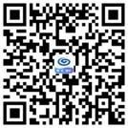
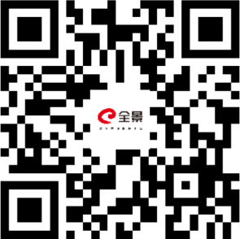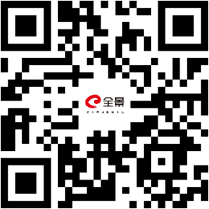
Chinese channel English channel Industrial Bank Official Client APP

III. Participants of the Company
Mr. Chen Xinjian, Acting Governor, Mr. Hua Bing, Board Secretary, senior management, and representatives of the Independent Directors.

IV. How Can Investors Join?
1. Investors may visit the above livestreaming websites or scan the above QR code to watch from 9:30 a.m. to 11:30 a.m. on August 31, 2023 (Thursday).

2. Investors may send their concerns and questions by email to the Company's Investor Relations Department at irm@cib.com.cn by 18:00 on August 28, 2023 (Monday). The Company will address the investors’ common concerns at the meeting.

V: Contact Person and Methods
Contact person: Mr. Zheng, Ms. Liu
Tel: 0591-87824863
Email: irm@cib.com.cn

VI. Other Matters
Investors may access the information and contents of the result presentation by visiting the "Investor Relations" section on the Company's website (www.cib.com.cn).
It is hereby announced.

Board of Directors of Industrial Bank Co., Ltd.
August 22, 2023

